(Thesis hard cover, all in English)

This sample applies to JBJI all programmes.

Title Font: Times New Roman, Size 16

Student Name e.g.Li Cheng (in Chinese Pinyin for Chinese ,Times New Roman, Size 16)
Student No. e.g. 2017000001
Major Economics
Supervisor e.g.Zhang Wei (in Chinese Pinyin,Times New Roman, Size 16)_
Date (dd/mm/yyyy) 17/03/2021

暨 南 大 学
本科生毕业论文

论文题目_中文题目，小三号宋体_

学 院 暨南大学伯明翰大学联合学院（小三号宋体）
学 系
专 业 经济学
姓 名 李成
学 号 2017000001
指导教师 张维
2021年 3月17日

Statement of Originality

I hereby declare that the thesis presented is the result of research performed by me personally, under guidance from my supervisor. This thesis does not contain any content (other than those cited with references) that has been previously published or written by others, nor does it contain any material previously presented to other educational institutions for degree or certificate purpose to the best of my knowledge. I promise that all facts presented in this thesis are true and creditable.

Signed: _________________ Date：（dd/mm/yyyy)
（Thesis Title )Analysis of the current situation of financial integration in the Great Bay Area
Abstract: A concise abstract should briefly state the purpose of the research and the main results. An abstract is often presented separate from the article, so it must be able to stand alone. The abstract should be about 150 words with 3-8 key words.
Key Words: One, Two, Three, Four

Contents
(The table of content should include all parts of the paper, such as introduction, conclusion, acknowledgement, appendix, and references. The page number of these sections should be listed as well.)
1. Introduction 1
2. Literature review on financial integration 1
2.1 Theoretical research on financial integration 5
2.2 Research on the economic development of the Greater Bay Area 6
3. The theoretical basis of financial integration 8
3.1 Regional financial theory 8
3.2 Theory of regional financial cooperation 9
3.3 Theoretical basis of F-H model 10
4. Analyzes the current situation of financial integration in Guangdong, Hong Kong and Macao 11
4.1 Coordinated development of financial institutions in Guangdong, Hong Kong and Macao 11
4.1.1 Coordinated development of financial institutions in Guangdong) 11
4.1.2 Coordinated development of financial institutions in Hong Kong 12
4.1.3 Coordinated development of Guangdong and Hong Kong financial institutions in Australia 13
4.1.4 14
4.1.5 15
4.2 Distribution and circulation of financial resources in Guangdong, Hong Kong and Macao 17

5. Empirical analysis of the financial integration of Guangdong, Hong Kong and Macao
20
6. Conclusion 30
Acknowledgements 32
Appendix……………………………………………………………………………………...33
References 36

1. Introduction
The main text should be typed in Font Times New Roman, Size 12. No indention is needed for the first paragraph. One Tab of indention is used for the rest paragraphs. Line spacing should be 1.5 times. Also there should be no empty lines between paragraphs.

2. Theoretical Background

2.1 Definitions
If any information or opinion is someone else’s copy right, you should give credit to the author (Smith, 2001). And in the end of the main text, a list of reference should include the details of this citation. Please do not use footnotes, or subscripts to label references. If the information you cited is not provided by a specific person, but an organization, the reference should still be treated the same way (World Bank, 2004). The name of organization will replace the last name of author. For Chinese names, please list the surname/family name of the author only (Liu，2005). And at the end of text, where you list all of your references, the author’s full name should be given.

2.2 Theories
If you have charts, tables for illustration, please make sure that they must be self explaining (readers can understand them without reading the text). Each table should have table number, table title, and source of information. Each illustration (chart) should also have figure number, figure title, and source of data. All tables must be numbered numerically, so must the figures. Table title is on top of the table. Figure title is at the bottom of the figure. Table and figure are in separate order.
Table 2-1 Theoretical Evolution of Political and Economic Integration
Integration Type | Removal of Internal Tariffs | Common External Tariff | Single Currency | Political Integration
Free Trade Area
Customs Union
Economic Union
Economic Federalism

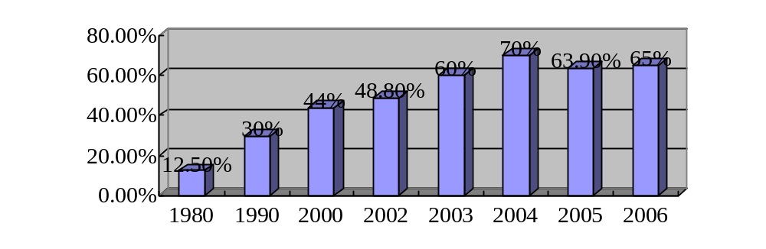
Figure 2-1 Foreign Trade Dependence Degree in China

5. The Case Studies

5.1 Case Study One
5.1.1 The Problem Presented
5.1.2 The Analysis of the Problem
5.1.3 The Solutions Suggested

5.2 Case Study Two
5.2.1 The Problem presented
5.2.2 The Analysis of the Problem
5.2.3 The Solutions Suggested

6. Conclusion
The conclusion should be a summary of the problems identified and analyzed, the solutions suggested and comments by the author.

Acknowledgements
Here the student can express gratitude to persons or organizations that have provided guidance or assistance in the process of writing thesis.

Appendix
If the student has some important information to attach to the thesis, but the information is too long in length, or not vital for understanding the thesis, it can be placed in the appendix. The appendix should also have reference for the source of information.

References
In this section, all the citations within the main text of the thesis should be found here. Some examples are listed below. Please note that the English references are in the front, in alphabetical order, and the Chinese references are in the back, also in alphabetical order of the Pin Yin.
The required elements for reference are:
Author(Surname, Given Name), year of publication, title of book chapter or journal article, title of book or journal, edition and publisher, location, page
Anderson Gary & Arsenault Nancy,1998, Fundamentals of Educational Research, Falmer Press, London.
Christensen Arthur, 2000, Income disparity in South Africa, in Christensen: The world of inequality, Random House, pp. 400-401. (This is a part of a book, which is a collection of different authors’ works.)
Smith Donald, 2001, The Effect of Taxation on Income Distribution, Journal of Economics, Volume 23, pp. 233-234. (This is an article from a journal)
World Bank, 2005, Income Distribution in Different Countries, p. 278. (This is a report by an institution)
Lin Jiezhen (林洁珍)，廖柏伟，1998，人口移入对经济的作用，移民与香港经济，商务印书馆，97-122页。
Liu Yong (刘勇)，2005，中国的不均衡收入分配，中国经济研究，34期，344页。(Example of Chinese reference)
National Bureau of Statistics of China (中国国家统计局)，2004，2004年统计年鉴, 网络链接：http: www.stats.gov/xxxx/xxxx.html (This is an example of web-sourced reference)
Wang Dongdong (王冬冬)，2003，中国的不均衡经济发展，经济出版社，545页。

Graduation Thesis Evaluation for Undergraduate Students
Supervisor’s Comments：

Marks：_______/100 Signature：
Date (dd/mm/yyyy):
Evaluator’s Comments:

Marks：_______/100 Signature：
Date (dd/mm/yyyy):
Dean’s Comments:

Marks: _______/100 Signature：
Date (dd/mm/yyyy):

